DSA_lab assignment Mayank Gupta

20BCE1538

AIM Implementation of Searching Algorithms

1. **Linear Search:**

#include <stdio.h>

//linear search function

int search(int arr[], int n, int x) { int i;

for (i = 0; i < n; i++)

if (arr[i] == x) return i; return -1;

}

int main(void) {

int arr[] = {15, 45, 8, 65, 52, 45, 65, 69, 12, 10};

int x; scanf("%d", &x); int n = sizeof(arr) / sizeof(arr[0]);

// Function call

int result = search(arr, n, x);

if (result == -1) printf("Element is not present in array"); else printf("Element is present at position %d", result + 1); return 0;

}

**ALGORITHM**

Step 1: Set i to 1

Step 2: if i > n then go to step 7

Step 3: if A[i] = x then go to step 6

Step 4: Set i to i + 1

Step 5: Go to Step 2

Step 6: Print Element x Found at index i and go to step 8

Step 7: Print element not found

Step 8: Exit

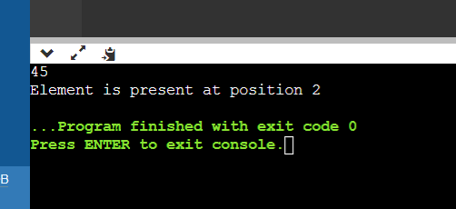

1. **Binary Search**

#include <stdio.h>

//linear search function

int binarySearch(int a[], int s, int e, int f) { int m;

if (s > e) // Not found return -1;

m = (s + e)/2;

if (a[m] == f) // element found return m;

else if (f > a[m])

return binarySearch(a, m+1, e, f); else

return binarySearch(a, s, m-1, f);

}

int main()

{

int c, first, last, n, search, array[100], index;

printf("Enter number of elements\n"); scanf("%d", &n);

printf("Enter %d integers\n", n);

for (c = 0; c < n; c++) scanf("%d", &array[c]);

printf("Enter value to find\n"); scanf("%d", &search);

first = 0; last = n - 1;

index = binarySearch(array, first, last, search); if (index == -1)

printf("Not found! %d isn't present in the list.\n", search);

else

printf("%d is present at location %d.\n", search, index + 1);

return 0;

}

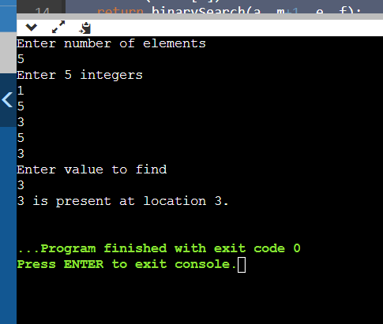

# ALGORITHM

1. Step 1: set beg = lower_bound, end = upper_bound, pos = - 1
2. Step 2: repeat steps 3 and 4 while beg **<**=end
3. Step 3: set mid = (beg + end)/2
4. Step 4: if a[mid] = val
5. set pos = mid
6. print pos
7. go to step 6
8. else if a[mid] **>** val
9. set end = mid - 1
10. else
11. set beg = mid + 1
12. [end of if]
13. [end of loop]
14. Step 5: if pos = -1
15. print "value is not present in the array"
16. [end of if]
17. Step 6: exit